SQL Queries
Query 1: Display All Gardeners
Purpose: To retrieve a list of all gardeners registered in the Garden Exchange database.
Interpretation and business relevance: The query displays the registered gardeners and their contact information. It helps the garden administrator identify gardeners and maintain an overview of the people participating in the gardening programme. This is a simple query because it retrieves information from a single table without joins or aggregate functions.
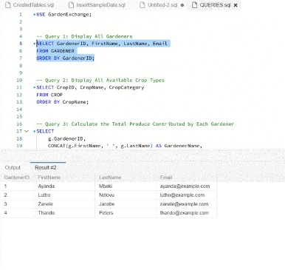

Query 2: Display All Available Crop Types
Purpose: To retrieve the crop names and categories stored in the database.
Interpretation and business relevance: The query lists the different crop types managed by GreenHarvest. It helps administrators see which crops are recorded in the system and supports decisions about crop variety and planting activities. It is a simple query because it retrieves selected columns from one table and sorts the results.
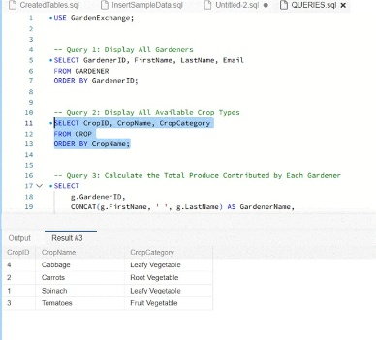
Query 3: Calculate the Total Produce Contributed by Each Gardener
Purpose: To determine the number of produce contributions and total quantity contributed by each gardener.
Interpretation and business relevance: Ayanda Mbeki contributed the largest total quantity, with 35 units across three contributions. This query helps GreenHarvest monitor each gardener's contribution to the community produce exchange and identify how much produce is being supplied.
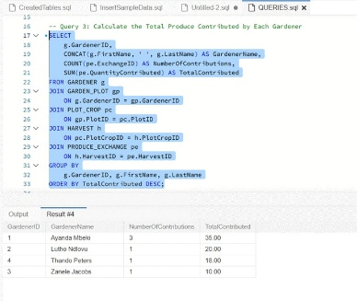
Query 4: Summarise Contributions by Crop Type
Purpose: To compare the total and average quantities contributed for each crop type.
Interpretation and business relevance: Carrots have the highest total contribution, at 30 units, while cabbage has the lowest, at 10 units. The query uses joins, grouping and aggregate functions to show which crop types contribute most to the exchange. This information can support future planting and produce-supply planning.
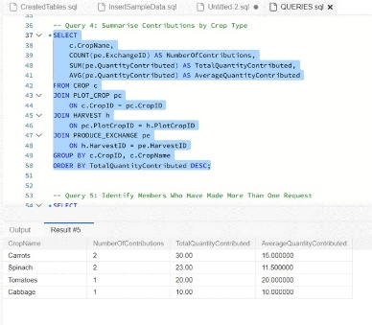
Query 5: Identify Members Who Have Made More Than One Request
Purpose: To identify members who have submitted multiple produce requests and calculate their combined requested quantities.
Interpretation and business relevance: Three members have each made two requests. Sipho Khumalo has requested five units in total, the largest combined quantity among these members. The query uses GROUP BY, COUNT(), SUM() and HAVING to identify repeat users and help the garden understand member demand.
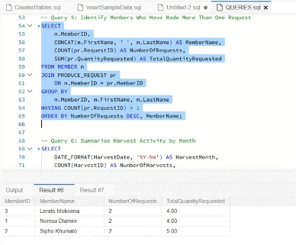
Query 6: Summarise Harvest Activity by Month
Purpose: To calculate the number of harvest records, total harvested quantity and average quantity harvested per month.
Interpretation and business relevance: Six harvest records are recorded for September 2026, with a total harvested quantity of 112 units and an average of approximately 18.67 units per harvest. The query demonstrates date formatting and aggregation. Additional records from other months would be needed to compare harvesting trends over time.
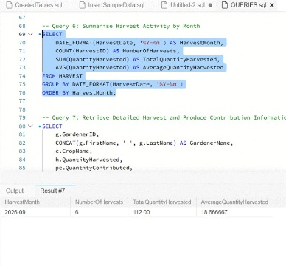
Query 7: Retrieve Detailed Harvest and Produce Contribution Information
Purpose: To connect gardeners, plots, crops, harvests and produce-exchange contributions in a single result.
Interpretation and business relevance: This query shows which gardener produced each crop, the quantity harvested, the quantity contributed to the exchange and the harvest date. For example, Lutho Ndlovu harvested 30 units of tomatoes and contributed 20 units. The query uses several joins to retrieve related information distributed across the database's normalized tables, helping administrators trace produce from the garden plot to the exchange.
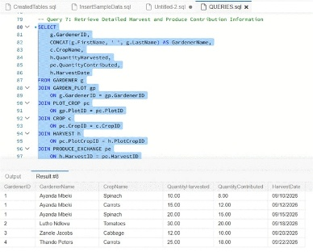
Query 8: Retrieve Member Requests and Collection Arrangements
Purpose: To display each produce request alongside the member's name, requested crop, request status and collection details.
Interpretation and business relevance: The query provides a consolidated view of member requests and their collection arrangements. The LEFT JOIN ensures that a request without an assigned collection day is still displayed. Request 8, for example, has no collection date because its CollectionDayID is NULL. This query helps administrators monitor pending, approved, rejected and collected requests and coordinate produce collection.
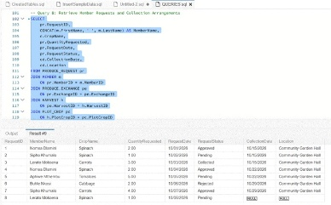
Query 9: Calculate the Remaining Available Quantity for Each Exchange Record
Purpose: To calculate how much produce remains after deducting approved and collected requests from the quantity contributed.
Interpretation and business relevance: Exchange 1 has eight units of spinach, of which two are reserved by an approved request, leaving six available units. The query uses joins, CASE, COALESCE() and aggregation to calculate availability. This is useful for managing produce allocation and helping prevent the garden from allocating more produce than it has available.
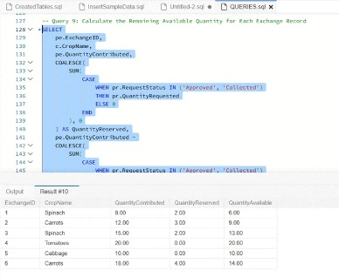
Query 10: Find Contributions Greater Than the Overall Average
Purpose: To identify produce-exchange records whose contributed quantity is greater than the average quantity contributed across all exchange records.
Interpretation and business relevance: Three contributions are greater than the average of approximately 13.83 units. The largest contribution is 20 units of tomatoes, followed by 18 units of carrots and 15 units of spinach. The subquery calculates the average dynamically, allowing the database to identify above-average contributions as new records are added.
